**Aim:**

To create a cloud-based Students Attendance System using a Cloud Service Provider (Zoho Creator) to demonstrate the Software-as-a-Service (SaaS) model, where student attendance details can be entered, managed, and accessed online.

**Procedure:**

1. Create Application

* Log in to Zoho Creator.
* Create a new application named *Students Attendance System*.

2. Design Form (Input Screen)

* Add the following fields:
  + Student Name (Text)
  + Course (Dropdown)
  + Present (Number)
  + Absent (Number)
  + Course Attendance (Number)
  + OD Request (Yes/No or Dropdown)
  + Grade (Dropdown)
  + Attendance Percentage (Formula field)

3. Define Formula Field

* Attendance Percentage = (Present / Course Attendance) × 100

4. Generate Report (Output Screen)

* Create a report to display all entered student attendance records.
* The report should automatically show the calculated Attendance Percentage for each student.

5. Publish Application

* Go to Settings → User Permissions → Make Public.
* Copy the public URL.
* Test in Incognito Browser to ensure it is accessible without login.

6. Verify Functionality

* Enter sample attendance data for students.
* Check that Attendance Percentage is auto-calculated and displayed in the report.

**Student Attendance Form (Public URL):**

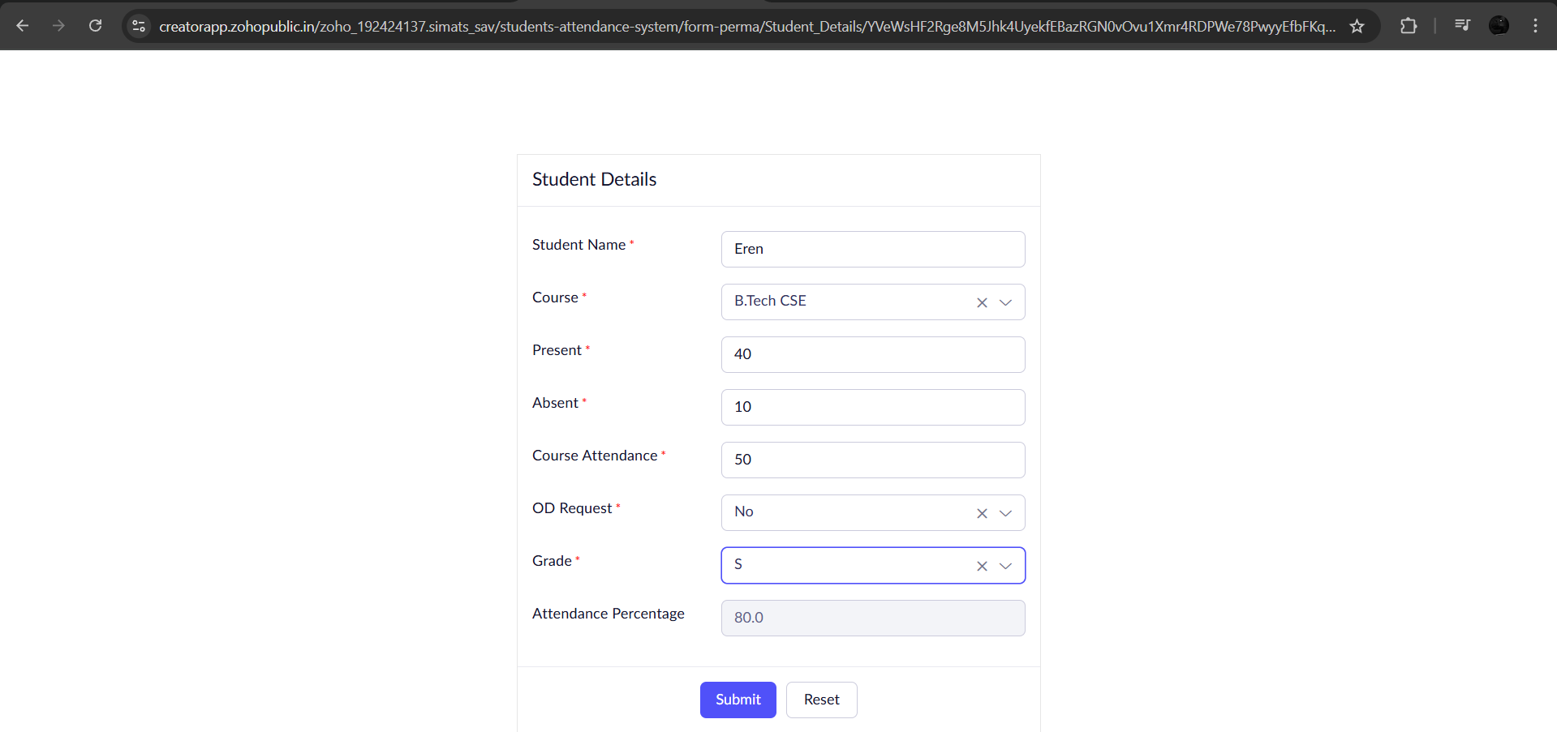

**All Student Attendance:**

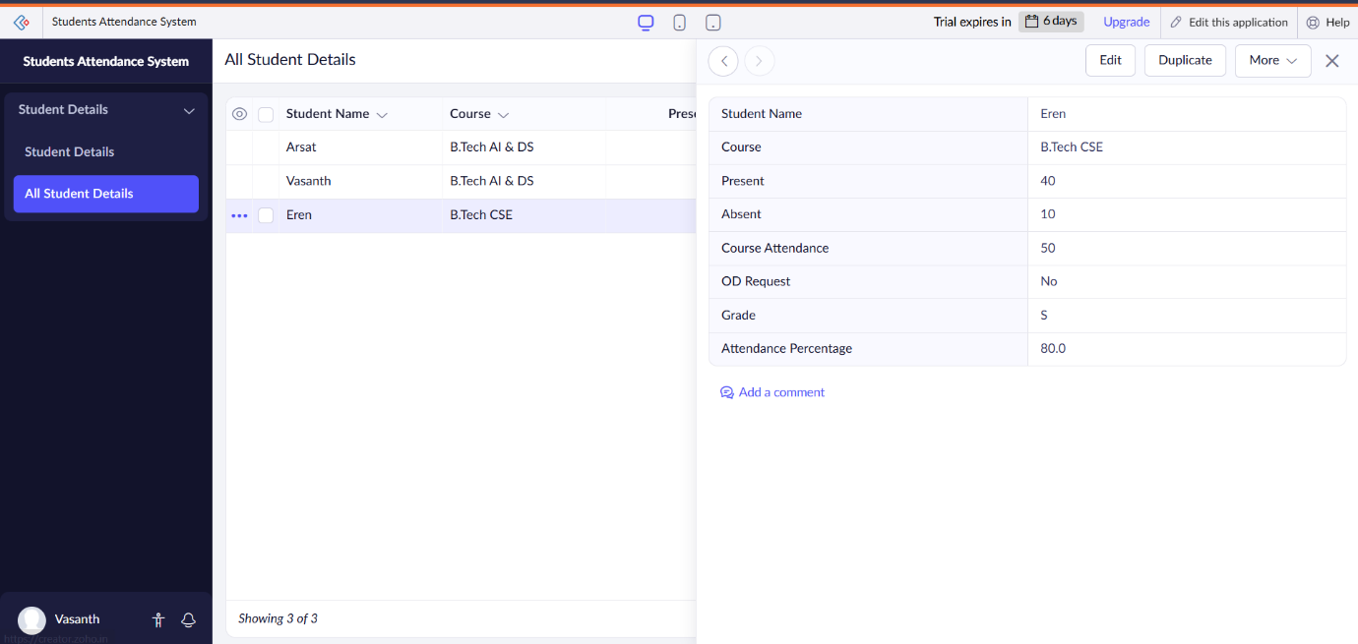

**Result:**

The Students Attendance System was successfully created and deployed on Zoho Creator. Student details such as Name, Course, Present, Absent, and OD Requests were entered through the form, Attendance Percentage was auto-calculated using formula fields, and the application was made accessible publicly as a SaaS application.